**STM32CubeProgrammer setup for production**

Steps

1. Make sure you have administrator rights before proceeding.
2. Download the latest version of STM32CubeProgrammer [here](https://www.st.com/en/development-tools/stm32cubeprog.html#overview) then install it.
3. Once installed, copy the EEPROM external loader file BR24L04W.stldr to Loaders.
4. Launch STM32CubeProgrammer.

This is the screen you should get.

1. Select required external loaders by clicking the ***EL*** button.

1. Next, prepare the firmware flashing sequence by clicking the ***Arrow Down*** button.

In the ***Download*** section, choose the firmware to program by using the ***Browse*** button.

Then, apply the same settings as shown below.

In the ***Automatic Mode*** section, apply the same settings as shown below.

Make sure to enter the option bytes commands string exactly as is.

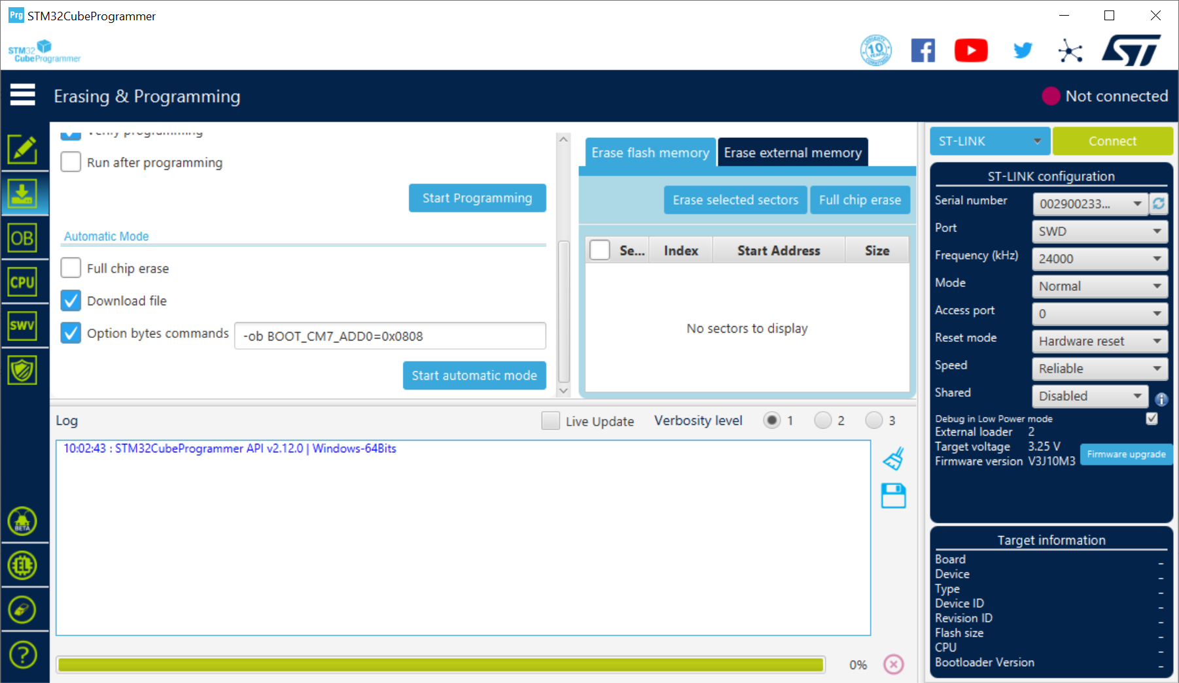

1. Enable firmware flashing process by clicking the ***Connect*** button.

1. Perform actual flashing process by clicking the ***Start automatic mode*** button.

Once flashing completes, the following screen will show.

As displayed in red in the ***Log*** window, disconnect the newly flashed device, then connect the next one to be flashed. This will automatically trigger the next programming process.

Once all devices have been programmed, click the ***Stop automatic mode*** to return to normal mode.

NOTE: Steps 1 to 6 need to be performed only once after installing the programmer software.

For further uses of the programmer, simply click the ***Arrow Down***, ***Connect***, and

***Start automatic mode*** buttons.